**Overview of the business scenario**

The business is similar to Ticketmaster, a comprehensive event management and ticketing solution platform. With an expansive reach spanning concerts, sports events, theatre productions, and more, our platform connects event clients, venues, and customers in a seamless ecosystem. Customers can explore a diverse range of events, check tickets with ease, and gain access to the events they're passionate about.

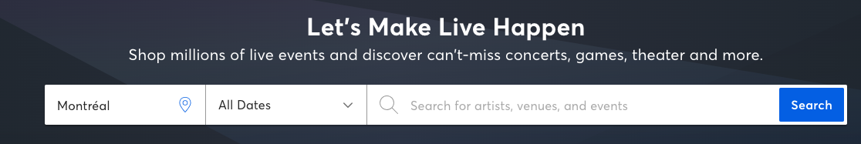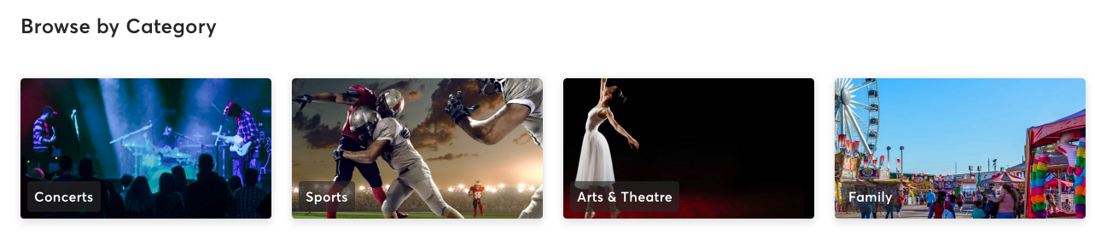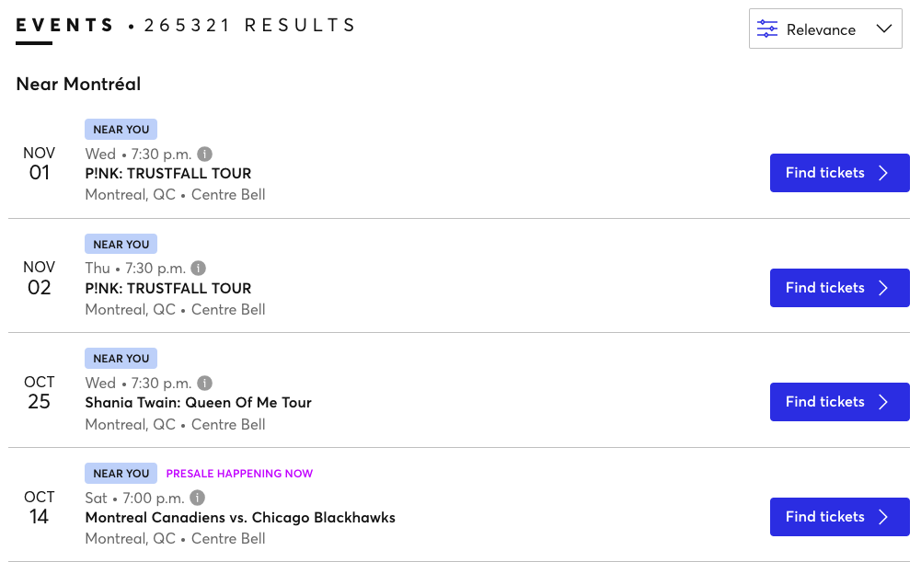

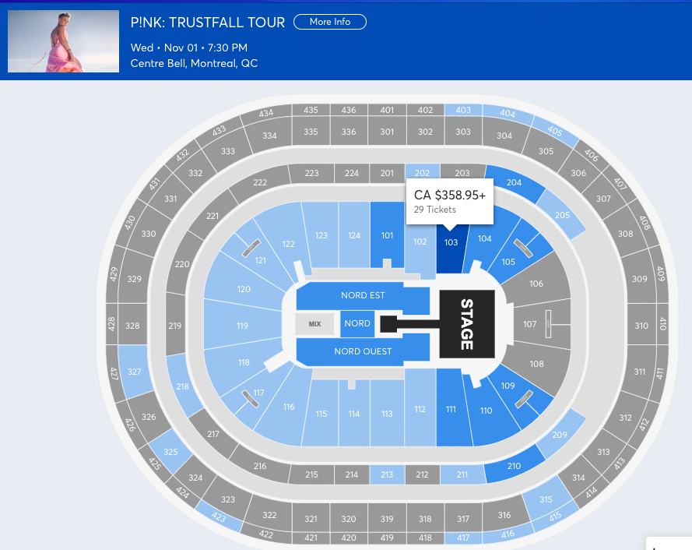

**Mission statement**

The purpose of the Ticketmaster-like database system is to effectively store, manage, and facilitate the exchange of event-related data. Our database fosters seamless collaboration and information sharing among clients, venues, and customers.

**Mission objectives**

To maintain (enter, update and delete) data on events

To maintain (enter, update and delete) data on venues

To maintain (enter, update and delete) data on address

To maintain (enter, update and delete) data on customers

To maintain (enter, update and delete) data on clients

To maintain (enter, update and delete) data on orders

To maintain (enter, update and delete) data on tickets

To maintain (enter, update and delete) data on seats

To maintain (enter, update and delete) data on reviews

To perform searches on events

To perform searches on venues

To perform searches on address

To perform searches on customers

To perform searches on clients

To perform searches on orders

To perform searches on tickets

To perform searches on seats

To perform searches on reviews

To track the status of events at venues

To track the status of orders and payments

To report on events

To report on venues

To report on address

To report on customers

To report on clients

To report on orders

To report on tickets

To report on seats

To report on reviews

**Business rules:**

* A customer must be associated with an address.
* An event must have at least one venue and can have multiple venues.
* An event can have multiple reviews from different customers.
* An order must be associated with a customer, and each order can have multiple tickets.
* A ticket must be associated with an event, a seat, and an order.
* Clients must have events associated with them, and each event must have payments to the client and Ticketmaster.
* Events must have clients, indicating partnerships between clients and events.
* Events must have a start and end date, and venues must host events during specific time periods.

**Business assumptions:**

* Customers have a single address associated with them (billing address), assuming customers cannot have multiple addresses. But multiple customers can have the same address.
* The system assumes that events can take place in multiple venues and across different categories and genres.
* Ticket prices are stored at the ticket level, assuming they remain constant regardless of the seat or order.
* Clients are assumed to be external entities or event organizers who collaborate with the event management system.
* The system assumes that events, orders, and tickets are linked together accurately for tracking purposes.
* Reviews are associated with customers and events, assuming customers can only leave reviews for events they attended.

**ERD**

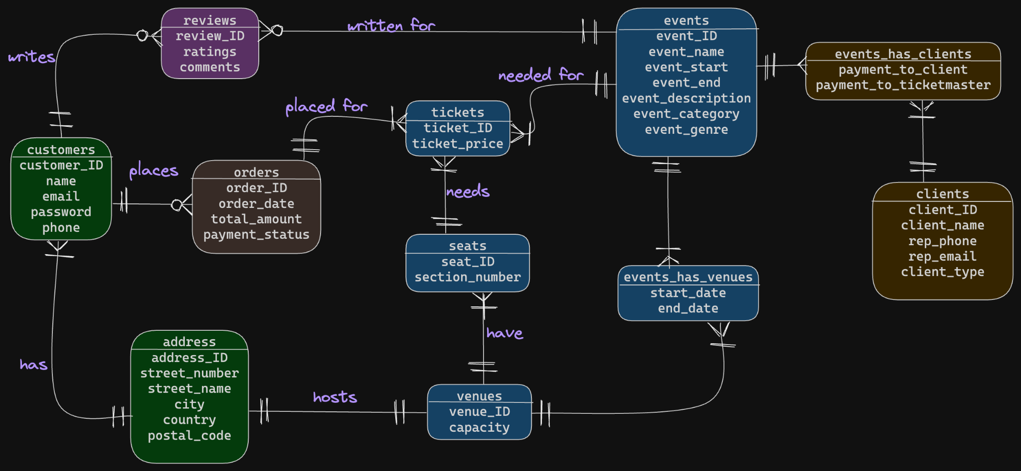

**Data Dictionary**

* **Description of Entities**

| **Entity Name** | **Description** | **Aliases** | **Occurrence** |
| --- | --- | --- | --- |
| events | Contains the information needed to identify a particular event held | activities | 1. One event can have many reviews; 2. Many events can be held in many venues (has “events_has_venues” relationship attribute); 3. Many events can be held by many clients (has “events_has_clients” relationship attribute) |
| venues | Contains the information needed to identify a particular venue that can hold events | sites | 1. One venue can have many Seats; 2. One venue can only have one address; 3. Many venues can hold many events (has “events_has_venues” relationship attribute) |
| address (we refer to billing address here specifically) | Address information that can be used for both customers and venues | location | 1. One address can only have one venue; 2. One address can have many customers (who may live together) |
| customers | Contains the customer's personal information who registered with our business | users | 1. Many customers can have one address (may live together); 2. One customer can place many orders; 3. One customer can post many reviews |
| clients | Client information about who is holding their events and selling tickets through our business | guests | 1. Many clients can hold many events |
| orders | Contains the order information of customers with dates, status and payment, etc. | purchase | 1. Many orders can belong to one customer; 2. One order can contain many tickets |
| tickets | Contains the ticket information such as the price of an event for customers | pass | 1. Many tickets can be in one order; 2. Many tickets can belong to one event; 3. Many tickets can have one Seat (for different events at the same venue) |
| seats | Contains information about the seats of customers at an event | spots | 1. Many seats can be in one venue; 2. One seat can be in many tickets (for different events at the same venue) |
| reviews | An entity that holds ratings and comments made by the customer for events | feedback | 1. Many reviews can be posted for one event; 2. Many reviews can be posted by one customer |

* **Description of Attributes**

(Please see the Google sheet submitted thank you)

**Relational Schema**

address(address_ID, street_number, street_name, city, country, postal_code)

Primary Key: address_ID

customers(customer_ID, name, email, password, phone, address_ID)

Primary Key: customer_ID

Foreign Key: address_ID References address(address_ID)

events(event_ID, event_name, event_start, event_description, event_end, event_category, event_genre)

Primary Key: event_ID

reviews(review_ID, rating, comments, customer_ID, event_ID)

Primary Key: review_ID

Foreign Key: customer_ID References customers(customer_ID)

Foreign Key: event_ID References events(event_ID)

orders(order_ID, order_date, total_amount, payment_status, customer_ID)

Primary Key: order_ID

Foreign Key: customer_ID References customers(customer_ID)

venues(venue_ID, name, capacity, address_ID)

Primary Key: venue_ID

Foreign Key: address_ID References address(address_ID)

seats(seat_ID, section_number, venue_ID)

Primary Key: seat_ID

Foreign Key: venue_ID References venues(venue_ID)

tickets(ticket_ID, ticket_price, event_ID, order_ID, seat_ID)

Primary Key: ticket_ID

Foreign Key: event_ID References events(event_ID)

Foreign Key: order_ID References orders(order_ID)

Foreign Key: seat_ID References seats(seat_ID)

clients(client_ID, client_name, rep_phone, rep_email, client_type)

Primary Key: client_ID

events_has_clients(event_ID, client_ID, payment_to_client, payment_to_ticketmaster)

Primary Key: event_ID, client_ID

Foreign Key: event_ID References events(event_ID)

Foreign Key: client_ID References clients(client_ID)

events_has_venues(event_ID, venue_ID, start_date, end_date)

Primary Key: event_ID, venue_ID

Foreign Key: event_ID References events(event_ID)

Foreign Key: venue_ID References venues(venue_ID)